

**Indian Institute of Information Technology, Una [HP]**

An Institute of National Importance under MoE

**Saloh, Una (HP) – 177209 Website:** [www.iiitu.ac.in](http://www.iiitu.ac.in/)

# PRACTICUM - IV Plan

|  |  |  |  |
| --- | --- | --- | --- |
| **Student Name:** | Mudit Dargar | **Student Roll No:** | 21319 |
| **Batch:** | B-19 | **Semester:** | IV |
| **Branch:** | IT | **Mentor Name:** | Dr. Naman Garg |

**Title of Work :**Web development and My Sql (Hospital Mangement System)

# Introduction:-

1. A hospital management system (HMS) is a software solution designed to automate and streamline hospital operations.
2. The primary goal of an HMS is to help hospitals deliver better patient care, reduce waiting times, and enhance overall patient satisfaction.
3. Overall, an HMS is an essential tool for modern hospitals, helping them to operate more efficiently, increase profitability, and provide high-quality care to patients.

1. **Motivation for the project:-**
2. Increased security: A hospital management system can store patient data securely and restrict access to authorized personnel only. This can prevent data breaches and protect patient privacy.
3. Improved efficiency: A hospital management system can automate many processes such as patient registration, appointment scheduling, billing, and inventory management.
4. Better decision-making: A hospital management system can provide real-time data and analytics, which can help hospital administrators make informed decisions about resource allocation, staffing, and other important issues.

# Technical/Research Issues:-

* + How python connect with sql.
  + How Webpages work with back-end part.
  + How connect frontend with back-end part.

# Objective:-

The main goal of a hospital management system is to provide a comprehensive, integrated solution that supports the efficient and effective delivery of healthcare services while improving patient outcomes and satisfaction.

# Methodology/Block Diagram:-

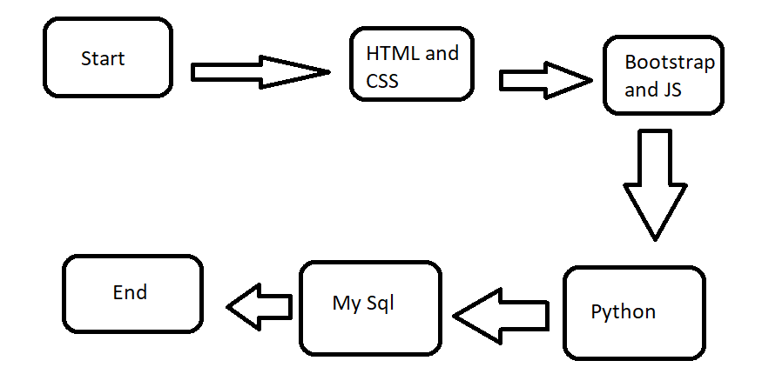

1. **Work Done:-**

* Studied html, Css, MySql and python.
* Connect the MySql and python.
* Connet the Webpages.

1. **References:-**
2. Sujarwoto, S., Soepriyanto, S., & Fitrianingsih, D. (2020). Design and Implementation of Health Management System using HTML, CSS and MySQL. Journal of Physics: Conference Series, 1529(1), 012031.
3. Nambiar, R. (2018). Development of a web-based health management system using PHP, HTML, CSS and MySQL. International Journal of Emerging Technologies in Learning, 13(8), 221-231.
4. Shinde, P., & Shinde, R. (2017). Design and implementation of web-based health management system using PHP, HTML and CSS. International Journal of Engineering and Computer Science, 6(8), 22587-22591.
5. Sanyal, S. K., Roy, D., & De, A. (2019). Design and development of a health management system using PHP, HTML, CSS, and MySQL. International Journal of Innovative Technology and Exploring Engineering, 8(9S), 128-131.
6. Ali, M. A., Kamal, M., & Ahmed, M. M. (2017). Development of an integrated health management system using PHP, HTML, CSS, and MySQL. International Journal of Computer Science and Mobile Computing, 6(8), 1-11.

**Student Signature Mentor Signature**